AM000-Asia-China-Warring States-Square-Four T-

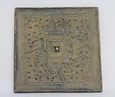

[CHINESE OLD BRONZE HANDWORK ART MIRROR ★★★★★](http://www.ebay.com/itm/330728023454?ssPageName=STRK:MEWNX:IT&_trksid=p3984.m1439.l2649) (330728023454)

Sale date: 05/15/12

Tracking number: --

GBP 0.01  
  
$0.02

+ GBP 18.00

shipping

**Paid with PayPal on May 17, 2012.**

**Shipped 05/18/12**